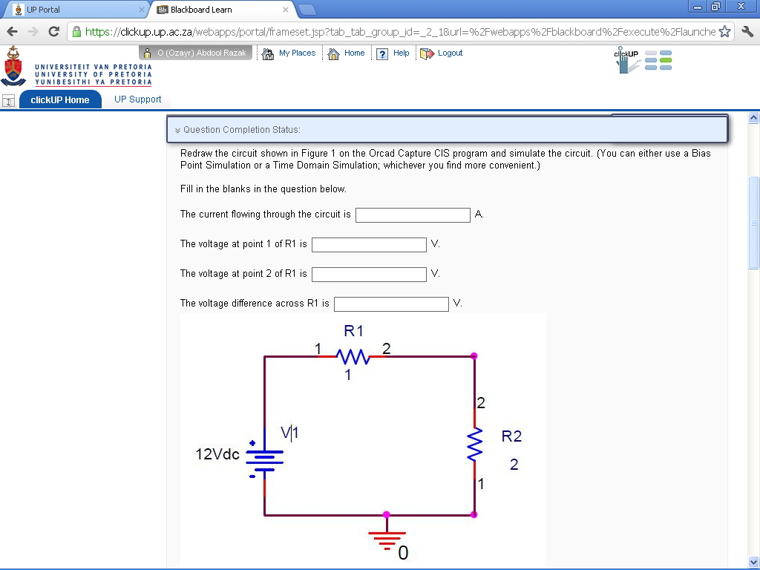
12
4
8
4
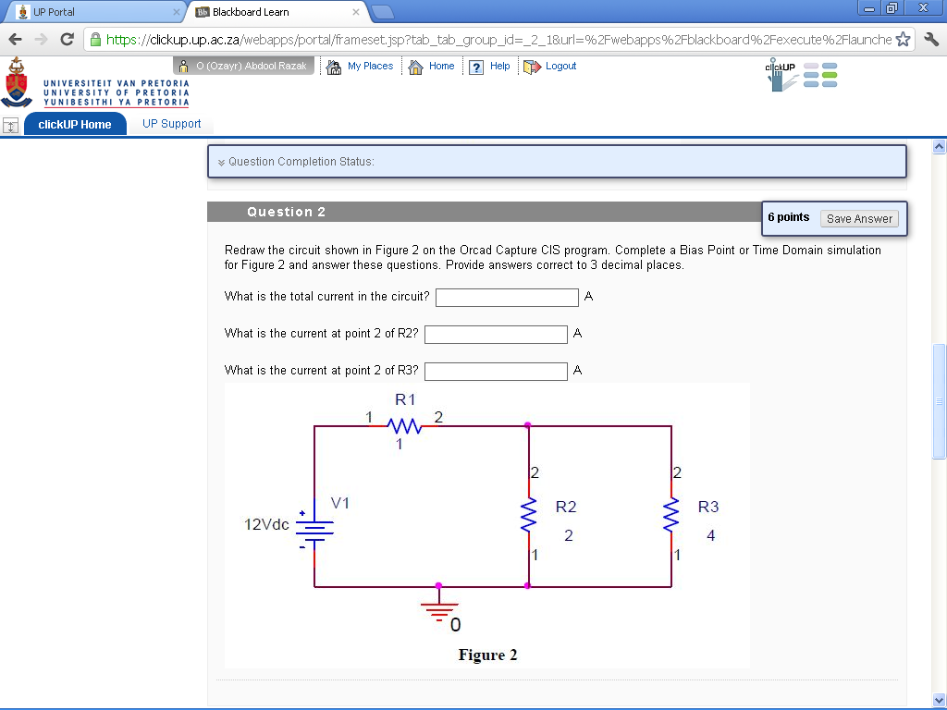
1.714
3.429
5.143
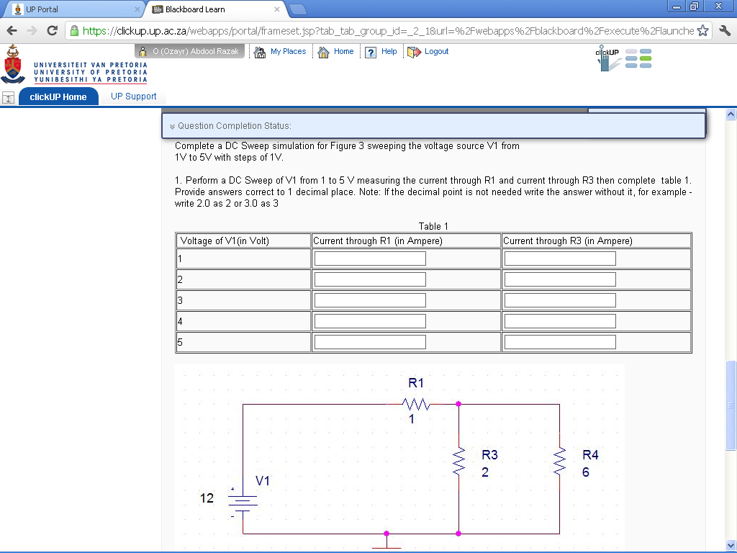
1.5
1.2
0.9
0.6
0.3
1.6
1.2
0.4
0.8
2
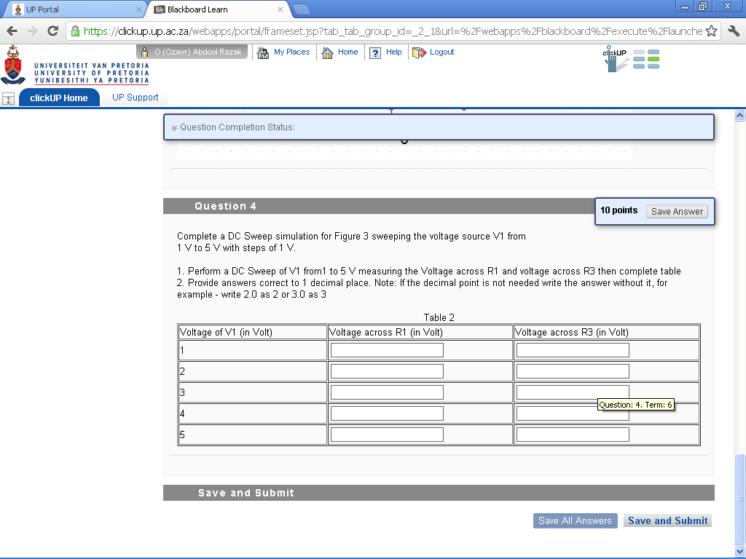
2.4
1.8
1.2
0.6
1.6
1.2
0.8
0.4
3
2

